# **Lab: Windows Server**

## **Overview**

Microsoft Windows Server is an OS that facilitates the hosting of critical authoritative Windows services on the network, including Active Directory, DNS, DHCP, and Domain Controller roles. Microsoft’s Evaluation Center allows for the use of Windows Server for 180 days free with full functionality. When deployed in tandem with Windows 10 Pro endpoints, once can establish a domained LAN with little more than VirtualBox and some relevant Microsoft documentation.

## **Scenario**

GlobeX LLC is a small startup in Springfield, OR with big dreams. According to its founder and CEO, Keytron Rusk, its mission is “to manufacture and deliver cutting edge products that contribute to sustainable, renewable energy.” By harnessing scientific breakthroughs made by [Belgian scientists in 2017](https://www.mic.com/articles/176543/scientists-figured-out-how-to-convert-polluted-air-into-clean-energy), GlobeX steadily developed international clientele with its groundbreaking AirPower machines that converted CO2 emissions and other toxins in the air to a source of electrical energy. The company is now making aggressive acquisitions and expansions in strategic areas of the world.

GlobeX is now at a technological crossroads with its IT infrastructure; it must either adapt its systems to modern standards, or be held back by its antiquated internal practices and expose itself to higher levels of risk. You have been hired at GlobeX as the new Systems Administrator reporting directly to Mr. Rusk. You will be responsible for both critical IT systems administration and network operations in this exciting new role.

After performing your initial survey of GlobeX systems, you gather that the company mostly runs virtual Windows 10 Professional 64-bit endpoints. However, GlobeX computer systems are inconsistently configured, resulting in a high rate of data loss, regulatory compliance violations and operational dissatisfaction. Your first task is to deploy Windows Server to the LAN so that the process of migrating from Workgroup to Domain can begin. You’ll need to shop for one within the company’s budgetary constraints, then deploy it.

## **Resources**

* [Windows Server 2019 ISO Download](https://www.microsoft.com/en-US/evalcenter/evaluate-windows-server-2019?filetype=ISO)
* [Windows 10 ISO Download](https://www.icloud.com/iclouddrive/01azgWsJOfzZaBbAj-G3sLWTg#Windows10)
* [AD DS Installation and Removal Wizard Page Descriptions](https://docs.microsoft.com/en-us/windows-server/identity/ad-ds/deploy/ad-ds-installation-and-removal-wizard-page-descriptions)

## **Prerequisites**

* Deploy pfSense router/firewall as a FreeBSD VM to your local VirtualBox Manager. This is performed in previous courses.
* Deploy a Windows 10 VM to your local VirtualBox Manager. This is performed in previous courses.

## **Objectives**

* Shop online for a server priced below $5,000 and discuss why you chose it. (Purchase not required!)
* Deploy Windows Server 2019 as a VM to your local VirtualBox Manager.
* Virtually plug the Windows Server VM into the pfSense VM. This should be the same LAN subnet as your Windows 10 PC.
* Assign the VM a static IP using DHCP reservation on your pfSense VM.
* Verify connectivity from Windows Server to Windows 10.
* Disable enhanced security feature on Internet Explorer in Windows Server.
* Verify internet connectivity on Windows Server.
* Perform Windows Update on the server until it is fully patched to latest possible version.
* Create a professional network topology diagram that reflects your current deployments.

## **Tasks**

Today you’ll be deploying Windows Server 2019 as part of the project to transition GlobeX from Workgroup to Domain on its network.

### **Part 1: Server Shopping**

* Choose a rack mount server for sale on the internet that costs less than $5,000. What’s the best deal out there for GlobeX and why did you choose the one you did?

**I know Dell, the cost to performance was fair, and its only a 6u server.**

* + List out the specs of the server you found (RAM, CPU, Storage, etc.)

**Detailed information below. In this case I gave the server:**

**32 GB RAM**

**2x E5-2697A 2.6 GHz 16 cores.**

**I went with a used server to save costs, and a blade system for upgradeability. Without knowing what GlobeX needs, I went with cost effective. This is scalable, has decent storage capacity (25 hotswap bays) and can be UPGRADED in a myriad of ways.**

* + Given the budget, what would be the pros and cons for Globex to purchase the server hardware instead of using a cloud provider.

**Again, IDK the operating costs, this is an impossible question to answer. I need a LOT more information!!! I say go cloud, AWS is more intuitive, and likely would cost less… depending on use.**

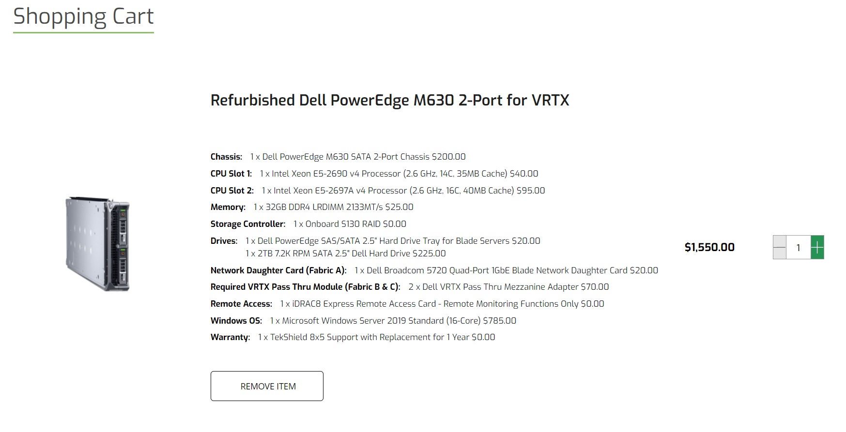

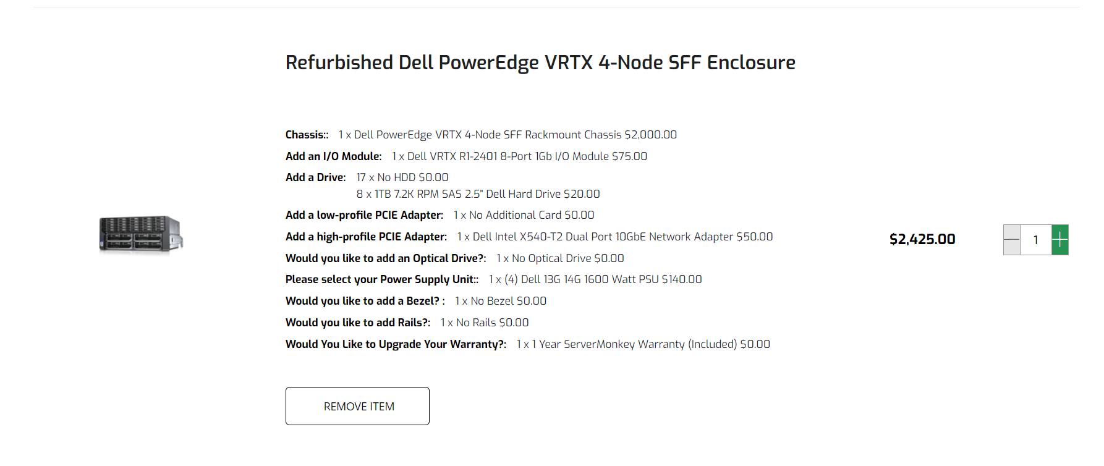

*No need to actually purchase a rack mount server for yourself, but you can if you want to!*

### **Part 2: Server Deployment**

* ~~Deploy Windows Server 2019 as a VM to your local VirtualBox Manager.~~
  + ~~Create a new VM. Document the CPU, RAM, and storage allocations you’ve made to this VM.~~
  + ~~Start by downloading the installer ISO and booting into it.~~
  + ~~During installation, select “Windows Server 2019 Standard Evaluation (Desktop Experience)”~~
  + ~~You’ll need to select partitioning just like a Win 10 installation.~~
* ~~When the OS is installed, export it to an OVA in case you need to start fresh on this OS again.~~
* ~~Install VirtualBox Guest Additions for this VM for optimal interactivity~~

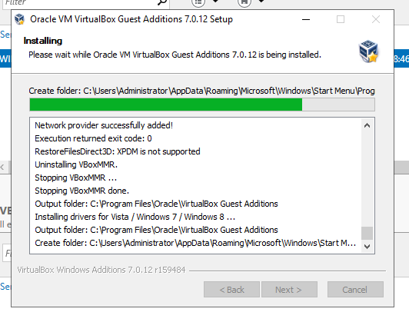

### **Part 3: Network Connectivity**

* ~~Virtually plug the Windows Server VM into the pfSense VM. This should be the same LAN subnet as your Windows 10 PC.~~

**I find myself loving kali more and more, I use it for setting up the pfsense**

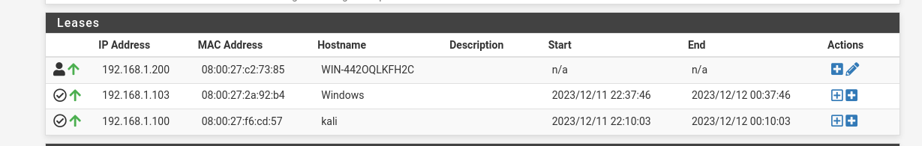

* ~~Assign the VM a static IP using DHCP reservation on your pfSense VM.~~
  + ~~Document the DHCP range.~~

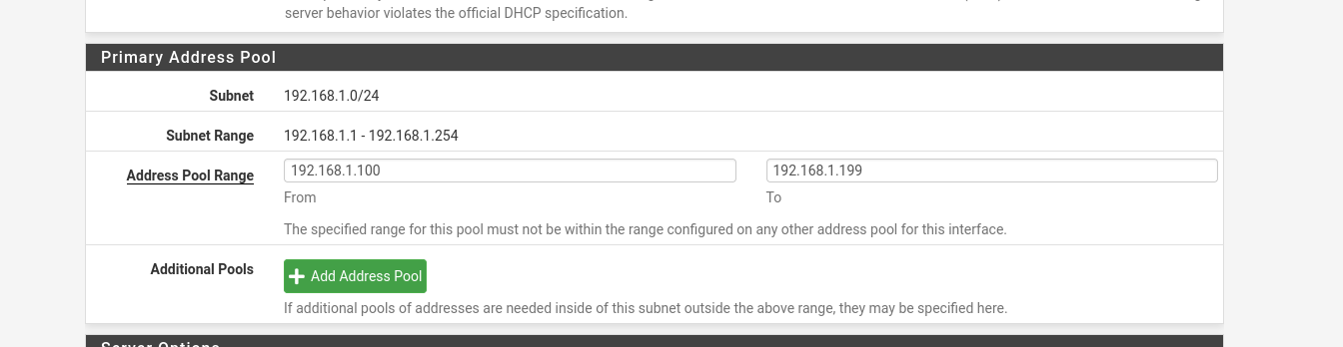

* + ~~Document the reserved IP you’ve allocated for the Windows Server. Why did you choose this IP, and what are your plans for future reserved IPs on this subnet? Explain how you’ll reserve them.~~

**I chose 192.168.1.200 as my server IP because it is a nice round number. Normally, I would assign IP addresses with topology in mind, our network won’t need that during this class as we aren’t networking multiple physical locations with a lot of devices. I like to reserve .2 - .9 for my server rack/infrastructure, and 10-99 for standard devices DHCP leases (network + internet), 100 - 199 for internet only devices (cell phones ect.), and 200 - 250 for network only (security cameras ect.)**

* + ~~Document the IP of Windows 10 VM. Did you also reserve it an IP (optional)? Explain your reasoning as if this were a production (real) network environment.~~

**The windows 10 VM is on DHCP (103). In this case the network env. Has 100-199 as the dhcp lease area, with the ability to connect to both the network and internet. If I assign static without a detailed topology, it would likely create more work for me in the future.**

* ~~Verify connectivity from Windows Server to Windows 10.~~

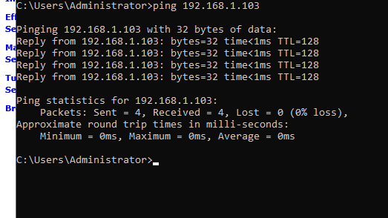

* ~~Disable enhanced security feature on Internet Explorer in Windows Server.~~

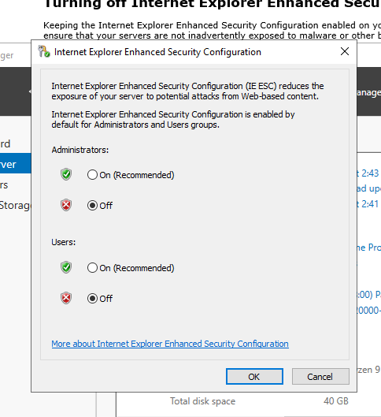

* ~~Verify internet connectivity on Windows Server using its Internet Explorer/Edge browser.~~

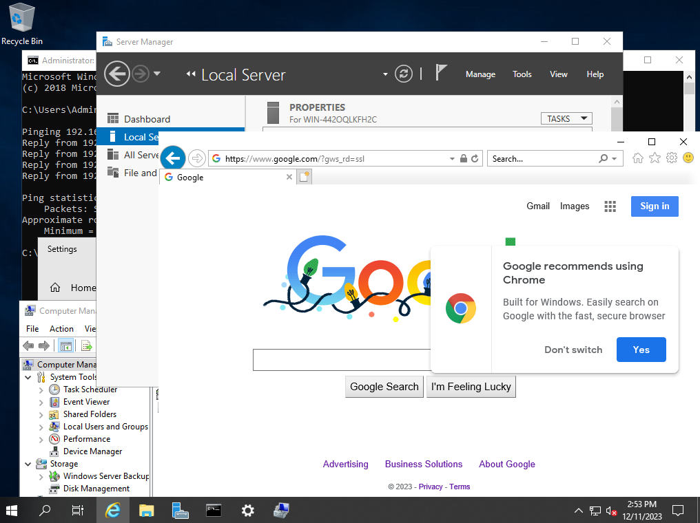

### **Part 4: Updates**

* ~~Perform Windows Update on the server until it is fully patched to latest possible version.~~

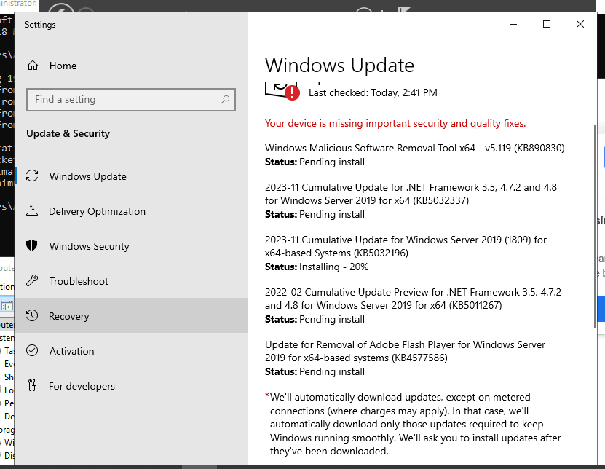

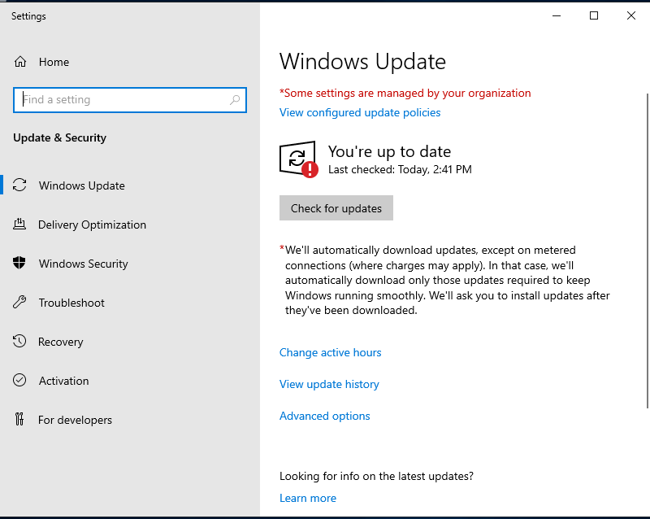

### **Part 5: Topology**

* ~~Create a professional network topology diagram that reflects your current deployments of the following assets:~~
  + ~~PfSense router/firewall~~
  + ~~Windows Server 2019~~
  + ~~Windows 10~~
* ~~Include IP address, OS, and computer name of each host near its icon.~~

